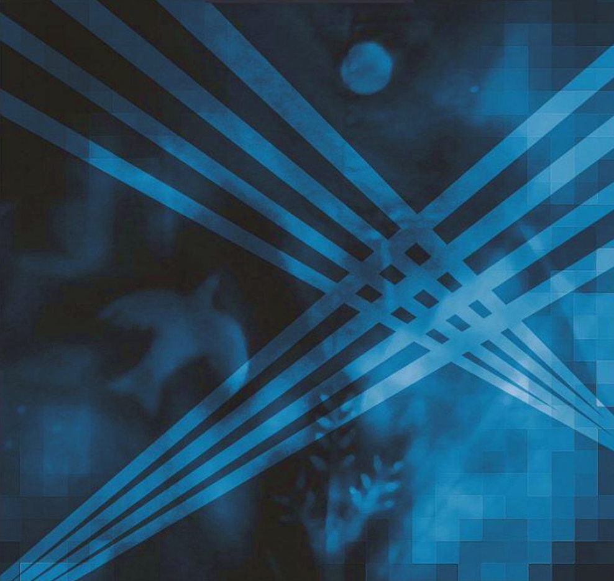
DRY LAND | a tribute to Marillion from the ‘H’-era v1..6
technical Rider Dry Land
Marillion Tribute Band, “H” era

Inhoudsopgave

General 2
INFO | REQUIREMENTS 2
Line up 3
Technical requirements 4
Amplification Drumkit 4
BACKLINE 4
Connection to FOH 5
Channel overview: 6
FOH 6
Sound engineer 6
Stage 7
Monitoring 7
Backup IEM possibility. 7
Video 7
Power supply 8
Stageplan DryLand 9
9
9
9
Appendix 10
Connection diagram 10
Patchlist 11

General
This rider is based on an example formation and the most ideal situation. If in reality the resources are not available to meet the demands of us as a band, please let us know in time. We can find a suitable solution for this in consultation.

INFO | REQUIREMENTS
Dry Land assumes a stage of at least 6 x 4 meters with a drum riser of 2 x 3 meters and a keyplayer riser of 2 x 3 meters. The set-up may change for other stage sizes. Please consult in advance, if this is the case. The stage should be easily accessible for technology and musicians
- DRY LAND assumes that there is a lockable dressing room for the band.
- DRY LAND assumes that the band and accompanying technicians will be provided with (soft) drinks and bottles of water on stage. (max 7 persons)
- DRY LAND expects a hot meal when setting up or playing around dinner time.
- DRY LAND reserves the right to invite people for a short-term viewing during a performance (always in consultation).
- DRY LAND plays according to the agreed time. Extra time is possible in consultation at an additional cost
- DRY LAND name and date of the performance. Payments for performances arranged through the booking office are made through the booking office.
- DRY LAND or the booking office will provide wage statements on request.
- DRY LAND only works with professional sound companies and equipment. In the case of PA not provided by the organizers themselves, the organizer must contact the sound company well before the performance.

Line up

Band member | Instrument
Wim Heerink | Bas + vocals
Hans Velders | Guitar + Vocals
Frank van Rees | Keys (2x)
Maarten Tappen | Drums
Francois Teering | Vocals, Keys, Guitar
na | Sound Engineer

Technical requirements

ICE has its own In Ear Monitoring system (Behringer X32 Rack) SO we are self supported on stage except for 2 active monitors we need.

BACKLINE
Dry Land will bring its own backline, consisting of:
- Drumkit
The drumkit is amplified by the venue, a drums return line (stereo) is profided to the SD8 of Dryland to compliment their in-ear monitors with drums.
  - Basedrum, 2x snare, hihat, 3x toms, 2x floor toms, 7x cymbals
- Guitar Axe FX (no cabinets or amplifier)
  - Signal split at X32 Rack for FOH (XLR male, stereo)
- Bass amplifying (no cabinet)
  - HARTKE HA 3500 A, Signal split at X32 Rack for FOH (XLR male)
- Keyboard + Synthesizers
  - Signal split at X32 Rack for FOH (XLR male)
- Backing tracks
  - Stereo signal (2x xlr from the Dryland X32)
- The lead vocal uses a Voice Live 2 to which the microphone is connected.
  - Signal split at X32 Rack for FOH (XLR male, phantom power through VoiceLive2, stereo)
- 4x Backing Vocals (Dry Land has NEEDS MICROFOONS FROM VENUE)
- DryLand has its own IEM systeem (In Ear Monitoring). It is a Behringer X32 + 2 x SD 8 Breakout + 2x MS 8000 XLR splitter
  - DryLand uses a Backing Tracks from a laptop, which through the X32 is offered to FOH. (Signal to FOH through X32 (XLR Female, stereo)

Connection to FOH
As mentioned above, DryLand uses its own In Ear Monitoring system (Behringer X32 rack) from which all signals, except the drumkit, are split to FOH, using 2x build in Behringer Utralink MS 8000. The signal is split before entering the IEM system. The dry signal from all instruments is thus presented to FOH through 2 multi cables, 2x SD8 stage box and 2 XLR cables for backing tracks.
All signals are offered in the following:
- 2x XLR multikabel with each 8x XLR male connector
(channels 1-8 en 9-16)
- 2x XLR female from the X32 for the backingtracks

Channel overview:

The overview below shows which channels contain which signals, devided by Device (Multicable 1, Multicable 2, SD-8 nr. 1, SD-8 nr. 2 and direct output from X32:
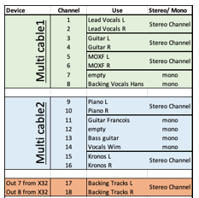

FOH

The PA, provided by the organizer, must be of good quality and have sufficient power for the location. The audience must be provided with good and undistorted sound. In addition, it must be able to handle the above occupation. PA includes all equipment outside the instruments. PA includes:

• External speakers (included Subs)
• Mixing console equipped with sound engineer
• Vocal Microphones + Stands
• Light installation
• All associated cabling
• Sound engineer who can build, patch and clear away the complete installation

Sound engineer
DryLand reserves the right to bring their own sound engineer who will perform the sound check and live mix. The installation, disassembly and generic operation of the PA is the responsibility of the supplier of the FOH PA.
However, a representative of the supplier of the FOH PA must be present before (for sound check) and during the performance to support.

Stage
Using the stage:
The stage must have a minimum size of 6 x 4 meters (width x depth). The drummer and the keayboardplayer requires a platform of 2 x3 meters in case of large stage.
We adapt to the situation as far as the set-up is concerned. In principle, we try to use the set-up as shown in the Stage Plan. Drums, left of center back of stage with keys to his right (seen from audience). Right in front of the stage guitar and left in front of the stage the bass guitar. Lead vocals (incl. keys and guitar) in the center front of the stage.

Monitoring
DryLand uses his own In -Ear Systeem, consisting off:
- Behringer X32 rack
- Behringer SD 8 (8 channel stagebox)
- Behringer Ultralink MS 8000 (2x)
- Shure PSM 300 wireless IEM (3x)
- Behringer PM 2 IEM (2x)
- 2x Multikabel (2x 8 XLR connectors)
EXCEPTION: For Feedback on the guitar is requested 1 monitor on the right front of the stage for the guitarist. Only the guitar signal needs to return to the monitor

Backup IEM possibility.
Dry Land does appreciate the option of having backup monitoring like XLR male cables and/or 6.3 inch Jacks, which are offered from FOH. This in case the IEM system of Dry Land should fail. The mix that is offered is then the FOH mix with a “++” for each band member's instrument(s). For the drum, must have the CLICK and BACKINGTRACKS .

Video

DryLand uses video images that are in sync with the music. These videos are automatically started from the laptop which is located directly next to the DryLand IEM X32 Rack. Because the laptop is connected to the Dryland IEM X32 Rack via USB-C, this distance cannot be increased. The client must offer an (HDMI) cable (connected to a projector) to the laptop at the location where the IEM X32 Rack is located.

The Venue will provide a videoprojector (with HDMI Input) and screen, capable of projecting video’s.The HDMI cable where Dryland connects its computer for the visueal must be available at the stage.

Power supply
Within a reasonable distance of the stage there should be two free, clean groups with 16 amps 220 volts (edge grounded). Everything according to government safety regulations. Any deviation from these provisions must be reported immediately.
It is possible to deviate from the aforementioned requirements in consultation. DRY LAND will never take decisions independently, but always in consultation with the client. This person remains responsible and contact person for matters relating to the sound system, unless this is provided by DRY LAND itself.

Stageplan DryLand
2XLR Stereo drums monitor (return from FOH to X32 Dry Land)

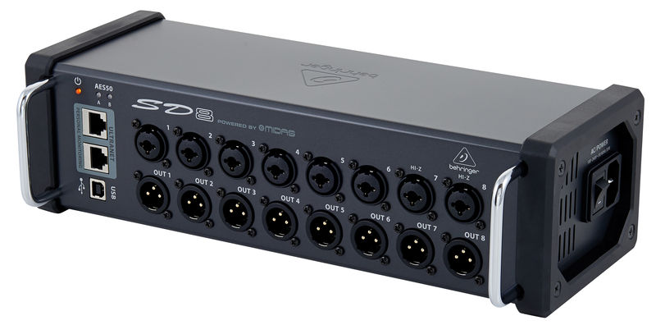

Laptop BCKNG


2x XLR backing track
FOH
8x XLR signals
8x XLR signals
X32 IEM
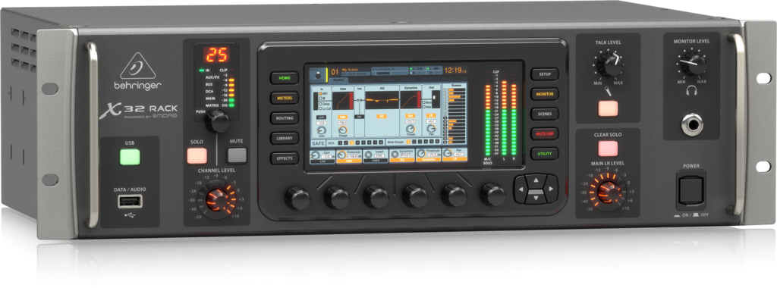
4x 230V
Video Screen (arranged by the venue in consultation with the booking office , incl projector)

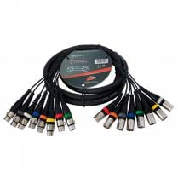

X32
Frank

Key’s
Own In Ear
Bass AMP
Wim

Bass Guitar
/ Vocals
3x 230V
Own In Ear

Bass Pedalb.
AXEFX3
HANS

Guitar / vocals
3x 230V

Own In Ear

Own In Ear

Voice Live2
Maarten

Drums / vocals

Key singer
Francois

Vocal 1 / Keys / Guitar
Own In Ear

3x 230V
5x 230V
2x 230V
HDMI Video
SD8 nr1
SD8 nr2

Key ‘s

Drumkit

Guitar

Video Projector

Appendix

Connection diagram, Backing vocals Hans are not on the picture but is necessary.

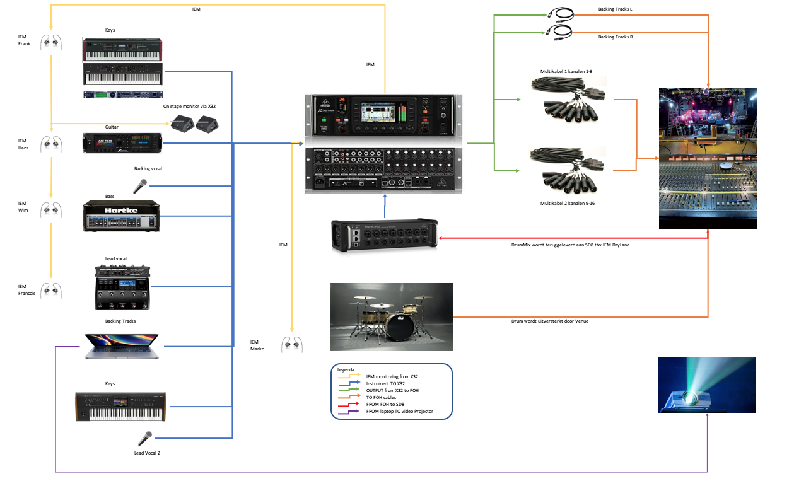

Patchlist

Device | Channel | Use | Stereo/ Mono
Multi cable1 | 1 | Lead Vocals L | Stereo Channel
Multi cable1 | 2 | Lead Vocals R | Stereo Channel
Multi cable1 | 3 | Guitar L | Stereo Channel
Multi cable1 | 4 | Guitar R | Stereo Channel
Multi cable1 | 5 | MOXF L | Stereo Channel
Multi cable1 | 6 | MOXF R | Stereo Channel
Multi cable1 | 7 | empty | mono
Multi cable1 | 8 | Backing Vocals Hans | mono
Multi cable2 | 9 | Piano L | Stereo Channel
Multi cable2 | 10 | Piano R | Stereo Channel
Multi cable2 | 11 | Guitar Francois | mono
Multi cable2 | 12 | Backing vocals Hans | mono
Multi cable2 | 13 | Bass guitar | mono
Multi cable2 | 14 | Backing vocals Wim | mono
Multi cable2 | 15 | Kronos L | Stereo Channel
Multi cable2 | 16 | Kronos R | Stereo Channel
Out 7 from X32 | 17 | Backing Tracks L | Stereo Channel
Out 8 from X32 | 18 | Backing Tracks R | Stereo Channel
SD-8 nr 1 | 1 | Kick | mono
SD-8 nr 1 | 2 | Snare | mono
SD-8 nr 1 | 3 | Tom 2 | mono
SD-8 nr 1 | 4 | Tom 3 | mono
SD-8 nr 1 | 5 | Floor 1 | mono
SD-8 nr 1 | 6 | Hats | mono
SD-8 nr 1 | 7 | Ovcerhead 1 | mono
SD-8 nr 1 | 8 | empty | mono
SD-8 nr 2 | 1 | Overhead 2 | mono
SD-8 nr 2 | 2 | Tom 1 | mono
SD-8 nr 2 | 3 | Snare | mono
SD-8 nr 2 | 4 | Tom 4 | mono
SD-8 nr 2 | 5 | empty | mono
SD-8 nr 2 | 6 | empty | mono
SD-8 nr 2 | 7 | empty | mono
SD-8 nr 2 | 8 | empty | mono

